Br. Peter Reddy OFS

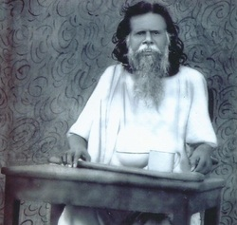
His full name was Paul Chinnappa Reddiar, aka Peter Reddy / Paradeshi Peter. He is also known as the greatest learned mendicant the world has ever seen. He was born at Perioor Ammapetei, Thirumangalam, Madurai district, Tamil Nadu. He was a teacher by profession with degrees in M.A, L.T (B.ed of today). Except Tamil and English, he learnt Hindi, Sanskrit, Malayalam, Italian, German, French, Hebrew and Aramaic after the age of fifty. He is credited to have written 9 books and over 50 Tamil devotional songs. His spirituality emphasized on evangelical poverty, evangelical mission, ascetic life and obedience to the call of Jesus and the Church.
“I do not look at the man who insults me but look at Jesus standing behind him. I will do as Jesus did when he was insulted.”
He was greatly devoted to the Holy Eucharist and to our Lady. He was influenced by St. Francis of Assisi and St. Alphonsa.
He renounced the world, became a beggar to practice the word of God and preached Christ. Even while working as a professor, he was never hesitant to sacrifice anything for evangelization. After a 3 day retreat in Amal Ashram, Trichy, he made his commitment for life to preach the Gospel as a Franciscan Mendicant Brother. On the instructions of Fr. Urban OFM Cap., in 1944, he renounced everything. He quit St. Xavier’s College, Palayamkottai, as a professor. He went out with a beggar’s bowl, the Holy Bible, putting on the brown habit of the capuchins minus the hood and tied a cord around his waist. Though he was an eminent scholar and a university professor, on many occasions he used to sit among the beggars, people irrespective of their class, caste, creed or color. He later on changed to saffron attire and went around with his begging bowl. He died on 21st June 1958 and is buried at Palayamkottai.

